README for CS 340 Project Two: Grazioso Salvare Dashboard
Amaro Terrazas
CS-340 Client/Server Development, Southern New Hampshire University
Published: June 17, 2025

Project Functionality

The Grazioso Salvare dashboard is a web application developed for Global Rain to assist Grazioso Salvare in identifying dogs suitable for search-and-rescue training using the Austin Animal Center Outcomes dataset. Built with Python, MongoDB, and the Dash framework, the dashboard provides an intuitive, user-friendly interface that minimizes user errors and training time. It follows the Model-View-Controller (MVC) design pattern, with MongoDB as the model, Dash components (e.g., tables, charts) as the view, and a custom CRUD Python module (animal_shelter.py) as the controller.

Key Features
- Interactive Filters: Radio buttons enable filtering by rescue type:
  - Water Rescue: Dogs like Labrador Retriever Mix, Chesapeake Bay Retriever, Newfoundland; Intact Female, aged 26–156 weeks.
  - Mountain/Wilderness Rescue: Dogs like German Shepherd, Alaskan Malamute, Old English Sheepdog, Siberian Husky, Rottweiler; Intact Male, aged 26–156 weeks.
  - Disaster/Individual Tracking: Dogs like Doberman Pinscher, German Shepherd, Golden Retriever, Bloodhound, Rottweiler; Intact Male, aged 20–300 weeks.
  - Reset: Restores the unfiltered dataset.
- Interactive Data Table: Displays filtered data with pagination (10 rows per page), column sorting, and single-row selection for map interaction.
- Geolocation Chart: Visualizes the selected dog’s location using location_lat and location_long fields, with a tooltip showing the breed and a popup displaying the animal’s name.
- Pie Chart: Illustrates the distribution of breeds in the filtered dataset.
- Branding: Incorporates the Grazioso Salvare logo and unique identifiers (“Module 5 Assignment - Amaro Terrazas” and “Dashboard by Amaro Terrazas”) for personalization.

Screenshots
The following screenshots demonstrate the dashboard’s functionality across different filter states:
- Starting State (Unfiltered):
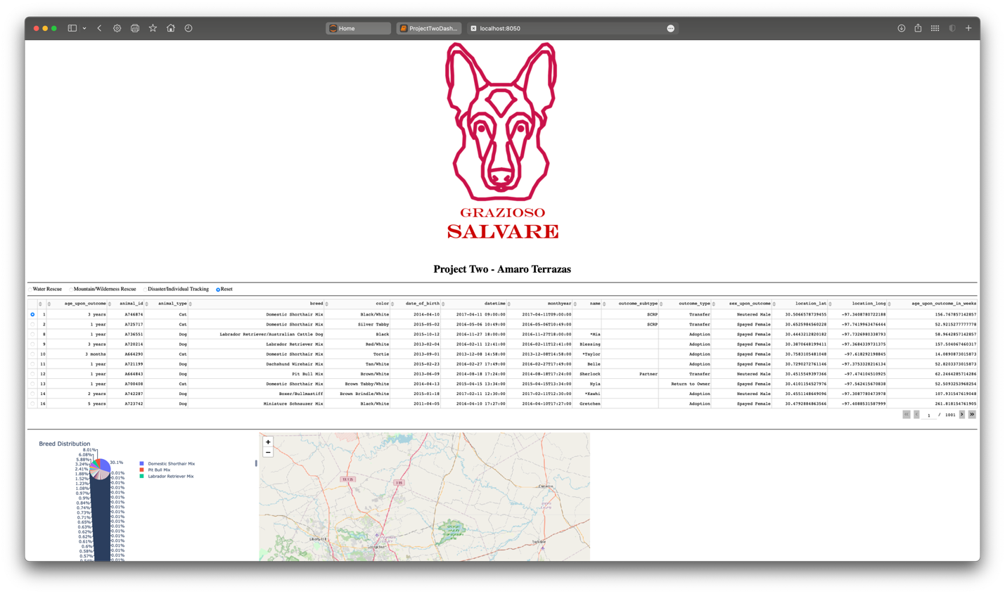
- Water Rescue Filter:
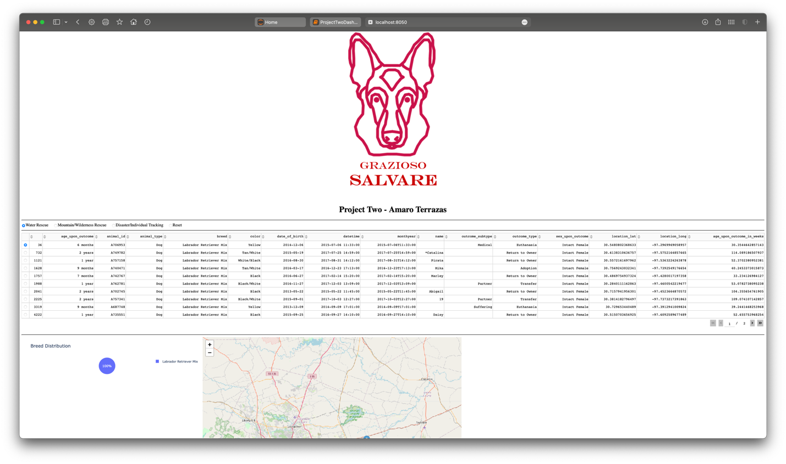
- Mountain/Wilderness Rescue Filter:
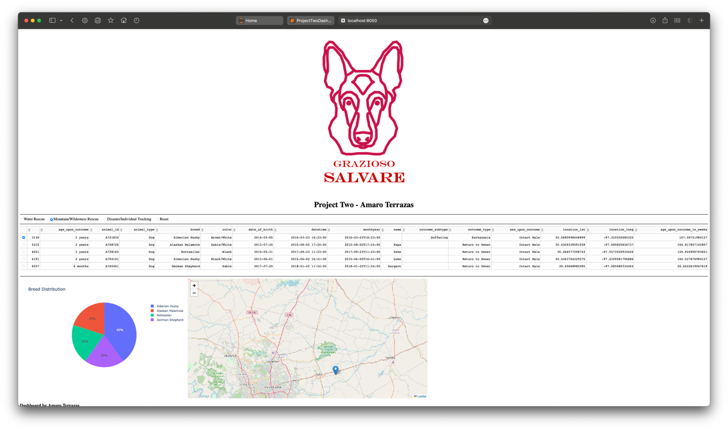
- Disaster/Individual Tracking Filter:
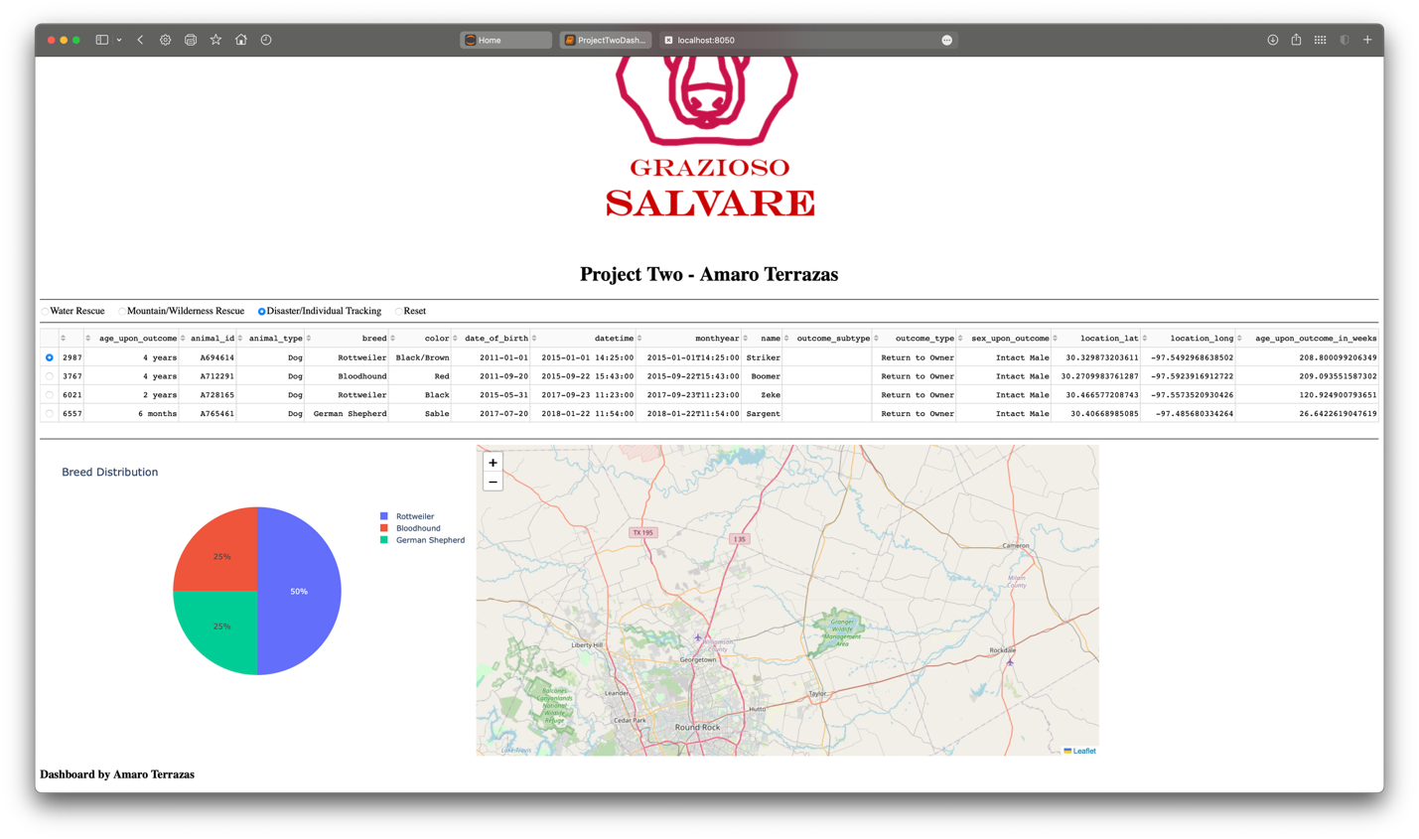
- Reset Filter:
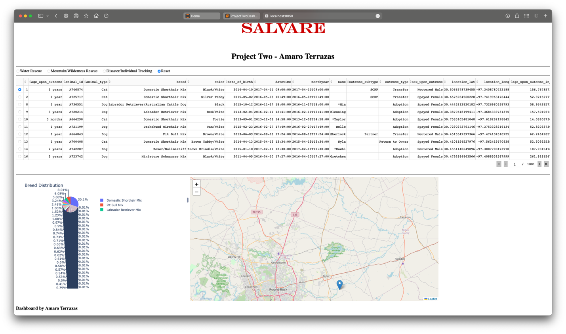

Tools and Rationale
The dashboard was developed using the following tools, selected for their compatibility, functionality, and alignment with Grazioso Salvare’s requirements:
- MongoDB:
  - Purpose: Acts as the model in the MVC pattern, storing the Austin Animal Center Outcomes dataset in the AAC.animals collection.
  - Rationale: MongoDB is a NoSQL database that supports flexible, JSON-like documents, ideal for the dataset’s varied schema. Its scalability and integration with Python via the pymongo library enable efficient CRUD operations. Authentication with the aacuser account ensures secure data access.
  - Version: 8.0.10, Community Edition.
- Dash:
  - Purpose: Provides the view (e.g., data table, charts) and controller (e.g., callbacks) components of the MVC pattern, rendering the web interface and handling user interactions.
  - Rationale: Dash is a Python-based framework for building interactive web applications without requiring JavaScript. It offers pre-built components like radio buttons, data tables, and charts, ensuring an intuitive user experience. The dash-leaflet library enables geolocation visualization, and Dash’s MVC structure aligns with the project’s design.
  - Versions: Dash 2.17.1, dash-leaflet 1.0.15.
- Python:
  - Purpose: The core programming language for the dashboard (ProjectTwoDashboard.ipynb) and CRUD module (animal_shelter.py).
  - Rationale: Python’s versatility, extensive libraries (e.g., pymongo, pandas, Dash), and readability support rapid development and seamless integration with MongoDB and Dash.
  - Version: 3.11.
- pymongo:
  - Purpose: Python driver for MongoDB, used in animal_shelter.py to perform CRUD operations (create, read, update, delete).
  - Rationale: Enables efficient interaction with MongoDB, supporting complex queries for filtering data based on rescue types.
  - Version: 4.8.0.
- pandas:
  - Purpose: Handles data manipulation, converting MongoDB query results into DataFrames for use in Dash components.
  - Rationale: Simplifies data processing and integrates seamlessly with Dash’s data table and chart components.
  - Version: 2.2.2.
- matplotlib:
  - Purpose: Included in the starter code for potential plotting routines (unused in the final dashboard but required to avoid import errors).
  - Rationale: Ensures compatibility with the provided code structure.
  - Version: 3.9.2.
- Jupyter Notebook:
  - Purpose: Development environment for writing, testing, and running ProjectTwoDashboard.ipynb.
  - Rationale: Supports interactive coding and immediate visualization of dashboard output, ideal for prototyping and debugging.

Resources
The following resources were used to develop and document the project:
- MongoDB Official Website: https://www.mongodb.com/
Provided documentation for MongoDB installation, configuration, and pymongo usage.
- Dash Documentation: https://dash.plotly.com/
Guided the implementation of Dash components and callbacks.
- dash-leaflet GitHub: https://github.com/thedirtyfew/dash-leaflet
Provided resources for integrating geolocation charts.
- Austin Animal Center Outcomes Dataset: Austin Animal Center. (2020). Austin Animal Center Outcomes [Data set]. City of Austin, Texas Open Data Portal. https://doi.org/10.26000/025.000001
Source of the dataset, modified with location_lat, location_long, and age_upon_outcome_in_weeks.
- SNHU Course Resources:
  - CS 340 Dashboard Specifications Document: Outlined dashboard requirements and rescue type queries.
  - Grazioso Salvare Logo: High-resolution PNG for branding.
  - Austin Animal Center Outcomes CSV: Sample dataset for testing.
- Python Style Guide (PEP 8): https://www.python.org/dev/peps/pep-0008/
Ensured code followed industry-standard best practices.
- Make a README: https://www.makeareadme.com/
Guided the structure and purpose of this README.

